Archived Delivery Report ( list truck drivers, via Rachel Sydney Kings Park NSW Warehouse – 101 )

Found in Pronto dataset Snooze Store : 130 – Moore Park Bedding :

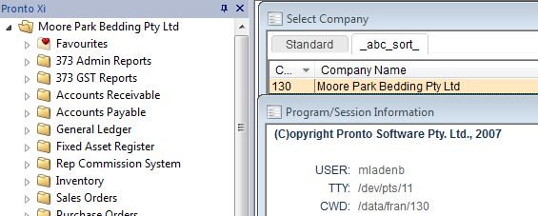

F11 Menu Shortcut is : SO.X111

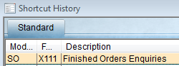

The menu item “ Archived Delivery Report “ – is in “Sales Orders” menu from the Operations menu :









When clicked / selected, the report first asks for a starting date :

The report then displays “ recognised query ” (ie. Please wait - it’s thinking ) :

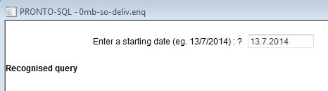

After a few seconds, **Processing Data** & **Query finished** will come up, along with the no. of records found – and an option to either : VIEW ONLY or SPOOL + VIEW :

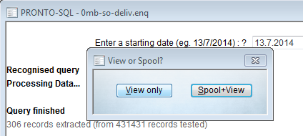

Choosing “View only” means the report is not saved as a spooled report, and just displayed :

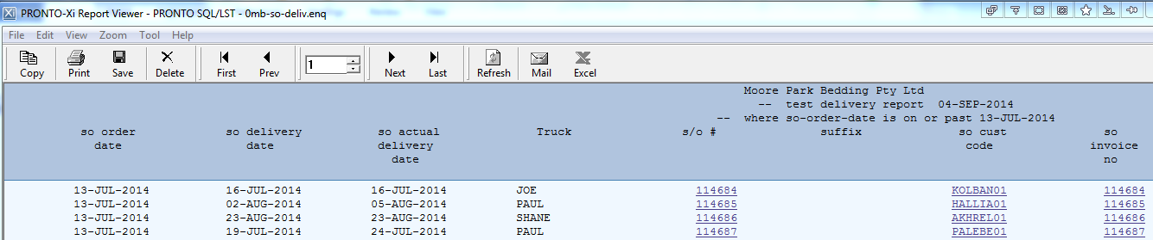

**Report Setup Requirements ( if report is not found in the above menu ) :**

SYS.M195 (user access control) :

Find User Login, then click SELECT button, choose the Store company/dataset, then click ACCESS button :

Click ENTRY button and enter ZUSR R233 :

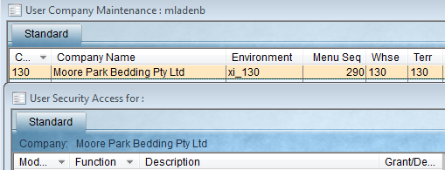



Then ESC escape back to main User Access Control datagrid for the selected user, then click B BUILD then U User Build then U User Build to re-build menu security for that user for that dataset.